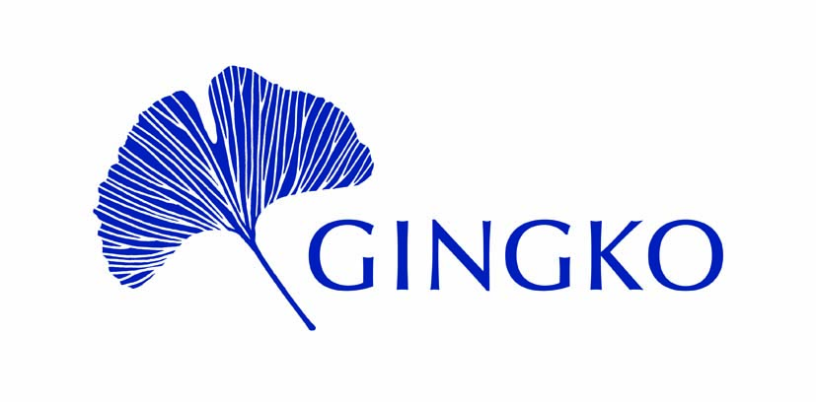
4 Molasses Row, London SW11 3UX
Registered Charity No. 1158548

Application for GINGKO Research Grant

(Please return your completed form to grants@gingko.org.uk by the 6 April 2024)

1. Title of the proposed research and the amount requested:

______________________________________________________________________________
- NAME (Full name & title):

Please attach a brief CV, of no more than 2 pages, for all applicants and for any key collaborators on the project.
______________________________________________________________________________
3. Address for Correspondence:

Tel. No.
E-Mail:

______________________________________________________________________________
- Details of Proposed Research
Please provide a 750-1000 word summary of your proposed research.
Your description should address the following matters:
- Rational for the project
- How you intend to deliver it
- Why are you suited to deliver it

GINGKO Research Grant application page 2

5. Financial
- Detailed estimate of costs (Please * the items, for which a GINGKO Research Grant is requested.)
(Please provide these costs in Pound Sterling)

- Amount requested/expected from other sources ________
(Please provide details.)

- Amount requested from GINGKO___________

______________________________________________________________________________
6. Please list previous grants received from GINGKO.

______________________________________________________________________________
7. Referees. Please give the names of two referees. Please note that it is the applicant’s responsibility to ensure that references are sent directly to GINGKO by the deadline.

- Name:
Address:

Tel. No.
E-mail:

- Name:
Address:

Tel. No.
E-mail:

CHECKLIST: Have you
• read and followed the Grant Guidance Notes and Terms & Conditions?
• checked your costings, including those requested from other sources?
• included the CVs?
• ensured that your references will reach GINGKO by the deadline (6 April)?
Please return your completed form to grants@gingko.org.uk.

GINGKO Research Grants: Guidance Notes

In a context of mistrust and misconceptions, Gingko works to improve mutual understanding between the Middle East and North Africa (MENA) and the West. One way that Gingko aims to do this is by providing grants to support academic research into aspects of MENA.

Gingko awards two kinds of academic research grant: the Research Grant and the Werner Mark Linz Memorial Grant.

The Research Grant is a small-scale award to fund academic research, conferences or symposiums on one or more of Gingko’s academic subject areas – the history, art history or religions of the MENA region – in any time period.

Gingko awards up to three Research Grants per year, normally up to a maximum of £3,000 for each grant.

Research Grants are for professional academic researchers based anywhere in the world.

Gingko particularly welcomes:
- applications from researchers in the MENA region and/or with MENA heritage;
- applications for collaborative projects, conferences or symposiums involving researchers both from the MENA region (and/or with MENA heritage) and the West;
- applications from researchers based at academic institutions in the MENA region or researchers of MENA heritage who plan to return to MENA academia; and
- applications for projects in regions and countries where there is limited financial support available for research.

Eligibility
Research Grants are for professional academic researchers based anywhere in the world. They must work for or have an official connection with a higher education institution or be able to provide other evidence of their status as professional academic researchers.

Subject area
The Research Grant can fund academic research, conferences or symposiums. The primary focus of the research, conference or symposium must be at least one of Gingko’s academic subject areas – the history, art history or religions of the MENA region – in any period.

Outcomes
Applicants should indicate their expected outcomes in their application. Outcomes should be specific and clearly defined. Gingko welcomes projects that will result in publication, preferably in a peer-reviewed journal or as part of a book, or else the presentation of a paper at a recognised conference or similar event.

Where the outcome of the research is a published book, grant recipients are encouraged but not required to submit their book proposal to Gingko. In any case, Gingko’s support must be acknowledged in any published outcome.

Grant recipients must submit a brief report (750 to 1000 words) to Gingko upon the completion of their project, detailing how the project turned out, assessing its outcomes and providing final accounts.

Schedule
Applicants should include a schedule for their project in their application. Gingko normally expects projects to be completed within two years of a Research Grant being awarded.

Budget
Applicants must include a budget. Applicants should submit a budget for the entire costs of their project, indicating as appropriate which parts of the budget will be funded by Gingko’s grant. Applicants should indicate other sources of funding and whether these have already been secured.

Financial Need
Applicants must include a declaration that without the grant they would not have the resources to carry out their proposed project.

Eligible Costs
Gingko Research Grants can cover direct costs of research projects, conferences or symposiums, but will not normally cover salary costs or institutional overheads. Allowable costs include fieldwork and research costs, costs of attending a conference or symposium, equipment, travel, event costs, and article-processing fees. We can fund some short-term wage costs, e.g. for research assistants, but we do not generally expect to fund salary costs, teaching replacements, normal living costs, or institutional overheads. If in doubt, please email Gingko at grants@gingko.org.uk .

Annual Deadline
6 April.

Application Procedure
Completed applications must be emailed to grants@gingko.org.uk by midnight (UK time) on 6 April. Decisions will be announced in June of the same year.

References
Two letters of recommendation must be submitted in support of each application and should be sent to grants@gingko.org.uk by midnight (UK time) on 6 April. The letters of recommendation must be from academics with professional, academic experience of the applicant. References must come from the academic’s work email account.

Terms and Conditions
Successful applicants will need to agree to Gingko's Terms & Conditions.

Assessment of Applications
Grant applications will be assessed by a panel of academic reviewers. Applications will be anonymised before assessment. Gingko aims to have at least one assessor from MENA or of MENA heritage on the judging panel. Decisions are based on the quality and practicality of the proposed research, conference or symposium, the costing of the work, the qualifications of the applicant to conduct the work, and the reports of referees. The decision of the panel is final. We regret that we cannot offer feedback to unsuccessful applicants.

Ethical Policy
Gingko expects all grant applicants and recipients to abide by its ethical policy, which is included in the terms and conditions for all grants. Gingko is a non-political, religiously neutral organisation, committed to non-discriminatory treatment of others in all aspects of our work. We operate in accordance with the UK’s Equality Act. We respect and celebrate diversity.

Further Questions
If you have any questions about the Gingko Research Grant, please email us on grants@gingko.org.uk.

Gingko interprets MENA broadly, to include the following states and territories: Algeria, Bahrain, Egypt, Iran, Iraq, Israel, Jordan, Kuwait, Lebanon, Libya, Morocco, Oman, Palestine, Qatar, Saudi Arabia, Syria, Tunisia, Turkey, United Arab Emirates and Yemen. Gingko may also extend it to include areas at some time ruled or influenced by the culture and religions of the MENA countries (e.g. the ‘Islamicate world’, the ‘Persianate world’ etc).
The ‘West’ for Gingko has so far mostly meant Europe and North America. But it could also include any other country in the ‘Global North’ or, in some contexts, any country with a dominant Christian culture (e.g. in South or Central America).

