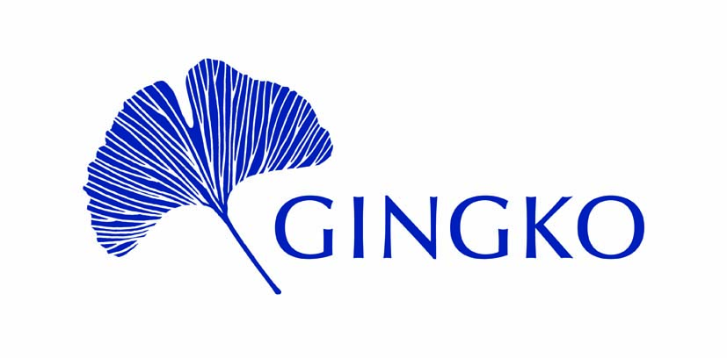
4 Molasses Row, London SW11 3UX
Registered Charity No. 1158548

Application for GINGKO Encounter Grant

(Please return your completed form to grants@gingko.org.uk by the 6 April 2024)

1. Title of the proposed encounter and the amount requested:

______________________________________________________________________________
- NAME (Full name & title):

Please attach a brief CV, of no more than 2 pages, for all applicants and for any key collaborators on the project.
______________________________________________________________________________
3. Address for Correspondence:

Tel. No.
E-Mail:

______________________________________________________________________________
- Details of Proposed Encounter(s)
Please provide a 750-1000 word summary of your proposed encounter(s).
Your description should address the following matters:
- Rational for the project
- How you intend to deliver it
- Why are you suited to deliver it
- Participants
- Expected impact

GINGKO Encounter Grant application page 2

5. Financial
- Detailed estimate of costs (Please * the items, for which a GINGKO Encounter Grant is requested.)
(Please provide these costs in Pound Sterling)

- Amount requested/expected from other sources ________
(Please provide details.)

- Amount requested from GINGKO___________

______________________________________________________________________________
6. Please list previous grants received from GINGKO.

______________________________________________________________________________
7. Referees. Please give the names of two referees. Please note that it is the applicant’s responsibility to ensure that references are sent directly to GINGKO by the deadline.

- Name:
Address:

Tel. No.
E-mail:

- Name:
Address:

Tel. No.
E-mail:

CHECKLIST: Have you
• read and followed the Grant Guidance Notes and Terms & Conditions?
• checked your costings, including those requested from other sources?
• included the CVs?
• ensured that your references will reach GINGKO by the deadline (6 April)?
Please return your completed form to grants@gingko.org.uk .

GINGKO Encounter Grants: Guidance Notes
In a context of mistrust and misconceptions, Gingko works to improve mutual understanding between the Middle East and North Africa (MENA) and the West. One way that Gingko aims to do this is by providing grants to support people organising interfaith and intercultural encounters between people from MENA and the West.

The Encounter Grant is a small-scale award to fund interfaith and/or intercultural encounters that bring together people from MENA and the West. The Encounters can be but need not be academic in nature. They must aim to improve mutual understanding between MENA and the West.

Gingko awards up to three Encounter Grants per year, normally up to a maximum of £3,000 for each grant.

The Encounter Grants are open to anyone anywhere in the world who can demonstrate the value of their project and their suitability to lead it.

Gingko particularly welcomes:
- applications from people in the MENA region and/or with MENA heritage;
- applications for projects led by people from both the MENA region (and/or with MENA heritage) and the West;
- applications for projects in regions and countries where there is limited financial support available for interfaith and/or intercultural encounters.

Eligibility
The Encounter Grants are open to anyone who can demonstrate the value of their project and their suitability to lead it. Previous experience organising and/or leading similar projects or events is welcome but not essential. Applicants must be committed to improving mutual understanding between MENA and the West and have an openness to encountering the Other.

Encounters
Projects for the Encounter Grant must bring together people from both MENA and the West in a direct and meaningful way. The encounter should be impactful – in other words, designed with the aim of creating real change in all participants. The encounter must be mutual – in other words, the encounter should be designed so that both sides are learning and growing. The encounter can be intercultural or interfaith or both.

Examples of possible encounters might include: a season of scriptural reasoning gatherings for participants of the three Abrahamic faiths, from MENA and the West; an educational project bringing together students from MENA or of MENA heritage with students from the West; a workshop, which encourages dialogue across ethnic and religious groups from MENA and the West, to build mutual understanding and prevent future conflict.

Outcomes and Impact
Applicants should indicate their expected outcomes in their application. Outcomes should be specific and clearly defined.

If the encounter is written about, either by the grant recipient or a third party, Gingko’s support must be acknowledged, wherever possible, in any published outcome.

Grant recipients must submit a brief report (750 to 1000 words) to Gingko upon the completion of their project, detailing how the project turned out, assessing how well the project achieved its expected outcomes and providing final accounts for the project. Where possible, grant recipients should conduct a brief survey of the impact of their project on its participants and include the results in their final report.

Schedule
Applicants should include a schedule for their project in their application. Gingko normally expects projects to be completed within two years of an Encounter Grant being awarded.

Budget
Applicants must include a budget. Applicants should submit a budget for the entire costs of their project, indicating as appropriate which parts of the budget will be funded by Gingko’s grant. Applicants should indicate other sources of funding and whether these have already been secured.

Financial Need
Applicants must include a declaration that without the grant they would not have the resources to carry out their proposed project.

Eligible Costs
Gingko Encounter Grants can cover direct costs of organising encounters, including event and technology costs, travel, accommodation, marketing and general expenses. The grant can be used to pay small fees to the organisers and/or others involved in delivering the encounters but these fees should normally total a third or less of the grant requested. If in doubt, please email Gingko at grants@gingko.org.uk.

Annual Deadline
6 April.

Application Procedure
Completed applications must be emailed to grants@gingko.org.uk by midnight (UK time) on 6 April. Decisions will be announced in June of the same year.

References
Two letters of recommendation must be submitted in support of each application and should be sent to grants@gingko.org.uk by midnight (UK time) on 6 April. At least one letter of recommendation should come from a professional contact of the applicant(s) who has professional experience of them in a context relevant to the Encounter Grant. If the project applied for is academic, then at least one referee must be a professional academic with professional academic experience of the applicant(s). Both references should come from professionals or individuals of good standing in their communities. These references must come from a work or official email address.

Terms and Conditions
Successful applicants will need to agree to Gingko's Terms & Conditions.

Assessment of Grants
Grant applications will be assessed by a panel of reviewers with experience in organising and leading interfaith and intercultural encounters. Applications will be anonymised before assessment. Gingko aims to have at least one assessor from MENA or of MENA heritage on the judging panel. Decisions are based on the quality and practicality of the proposed encounter(s), the costing of the work, the qualifications of the applicant to conduct the work, and the reports of referees. The decision of the panel is final. We regret that we cannot offer feedback to unsuccessful applicants.

Ethical Policy
Gingko expects all grant applicants and recipients to abide by its ethical policy, which is included in the terms and conditions for all grants. Gingko is a non-political, religiously neutral organisation, committed to non-discriminatory treatment of others in all aspects of our work. We operate in accordance with the UK’s Equality Act. We respect and celebrate diversity.

Further Questions
If you have any questions about the Gingko Encounter Grant, please email us on grants@gingko.org.uk.

Gingko interprets MENA broadly, to include the following states and territories: Algeria, Bahrain, Egypt, Iran, Iraq, Israel, Jordan, Kuwait, Lebanon, Libya, Morocco, Oman, Palestine, Qatar, Saudi Arabia, Syria, Tunisia, Turkey, United Arab Emirates and Yemen. Gingko may also extend it to include areas at some time ruled or influenced by the culture and religions of the MENA countries (e.g. the ‘Islamicate world’, the ‘Persianate world’ etc).
The ‘West’ for Gingko has so far mostly meant Europe and North America. But it could also include any other country in the ‘Global North’ or, in some contexts, any country with a dominant Christian culture (e.g. in South or Central America).

