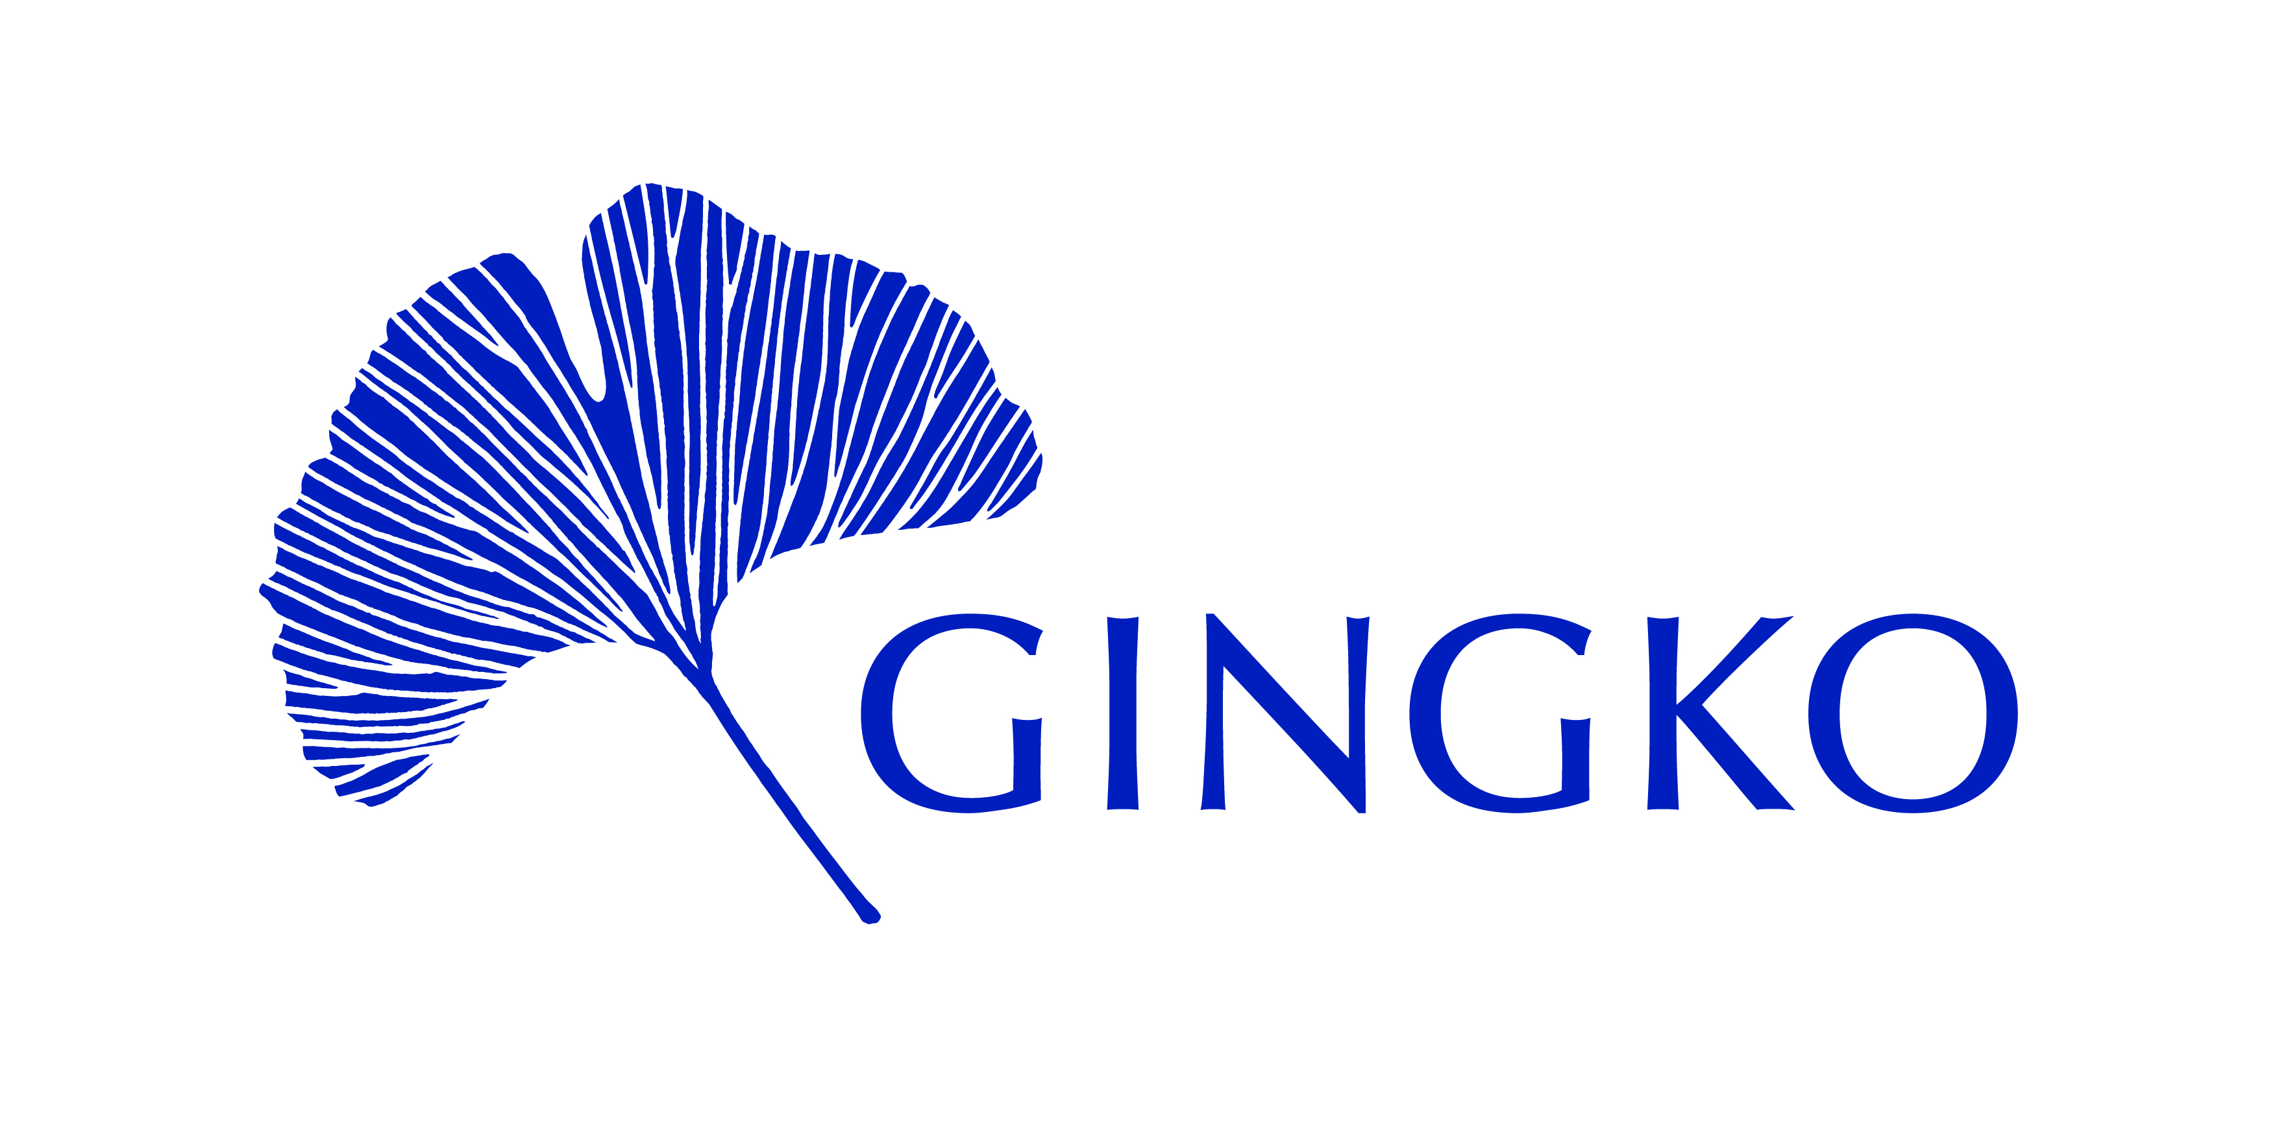

Gingko Fellowship Collaborations Prize
APPLICATION FORM

- Name, email and phone number of key contact for this project

- Full names of all Gingko Fellows involved

- Please outline the nature of the proposed activity in 500 words

- Please outline the goals of the activity and its intended impact

- Please outline the timeline/key milestones for this project

- What is your budget? (maximum is £1,000). Please provide an indicative breakdown of anticipated costs.

- How will you evaluate the success of the project, and how will you know it has achieved its goals?

- What is the bank account to which the grant money, if this application is successful, should be paid (please note that this must be a UK bank account)?

