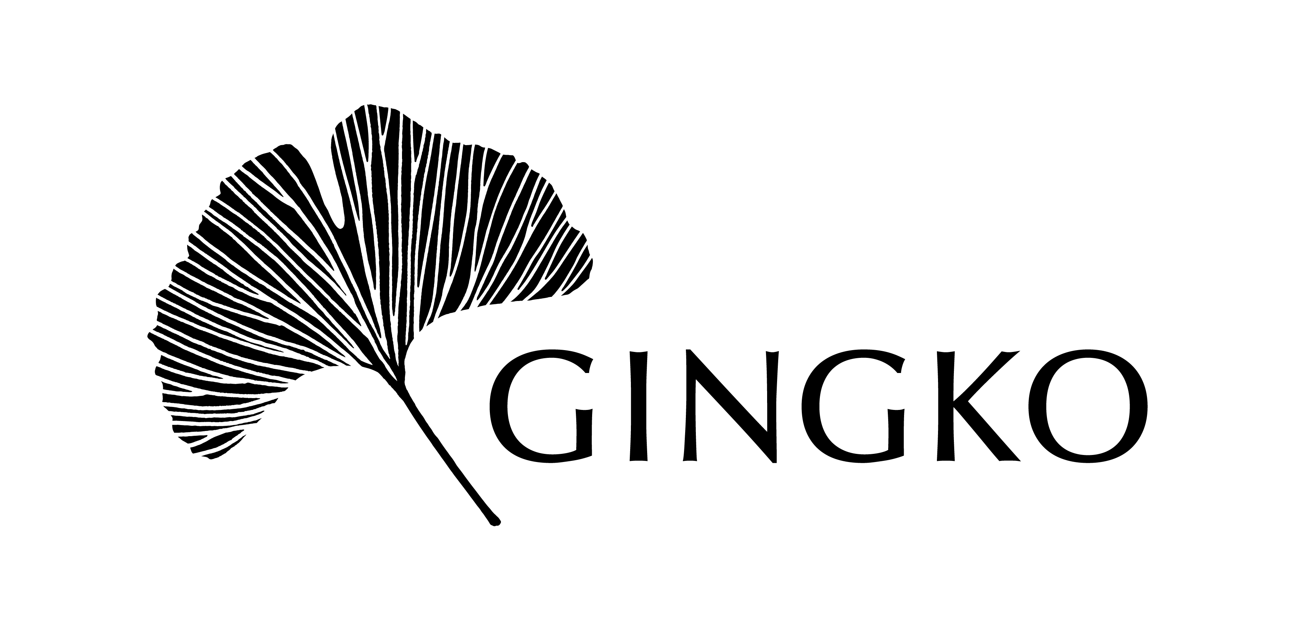

UK Charity No: 1158548
Gift Aid Declaration Form
Boost your donation by 25p of Gift Aid for every £1 you donate

Gift Aid is reclaimed by the charity from the tax you pay for the current tax year. Your address is needed to identify you as a current UK taxpayer.

Details of Donor:
Name: Click here to enter text.
Full Home Address: Click here to enter text.

Postcode: Click here to enter text.
Phone Number: Click here to enter text.
Email: Click here to enter text.
Gift Aid Declaration:
Please tick the boxes below.
I am a UK taxpayer and I agree to Gingko claiming tax on my donation of £__________ and any donations I make in the future until further notice. Please treat my donation(s) as Gift Aid donations. By ticking this box I confirm that I understand that if I pay less Income Tax and/or Capital Gains Tax than the amount of Gift Aid claimed on all my donations in that tax year it is my responsibility to pay any difference.
I am happy to be contacted about this donation.
Signature: Click here to enter text. Date: Click here to enter a date.
Please return the form to the address below or send it by email to:
Dr Barbara Haus Schwepcke, Gingko, 4 Molasses Row, London SW11 3UX
Tel: +44 (0) 203 6379730 barbara@gingkolibrary.com

Please notify the charity if you:

- Want to cancel this declaration
- Change your name or home address
- No longer pay sufficient tax on your income and/or capital gains

